BACKEND DOCUMENTATION
INVENTORY MANAGEMENT SYSTEM
Introduction
Team ID:
Team Leader:
Vennila S

Team Members:
Soniya P
Ghandhimathi R
Sathya S

Objective
The main objectives of the Inventory Management Backend are:
- To store product information in a database.
- To manage stock quantity automatically.
- To add, update, and delete product details.
- To track inventory transactions.
- To provide secure API endpoints for the frontend application.

Technologies Used
The backend system is developed using the following technologies:
- Node.js – Runtime environment for executing JavaScript on the server.
- Express.js – Framework used to build APIs and handle server requests.
- MongoDB – Database used to store inventory data.
- Mongoose – Library used to connect Node.js with MongoDB.
- Postman – Tool used for testing API endpoints.

System Architecture
The backend follows a client–server architecture.
Components:
- Client (Frontend) – Sends requests to the backend.
- Server (Backend) – Processes requests and performs logic.
- Database – Stores inventory data such as products and stock levels.

Database Design
Product Collection
The product collection stores details of each item.
Fields include:
- Product ID
- Product Name
- Category
- Quantity
- Price
- Supplier
- Date Added
Backend Functionalities
Add Product
- Allows users to add new products to the inventory.
View Products
- Displays all products stored in the database.
Update Product
- Allows modification of product details such as price or quantity.
Delete Product
- Removes a product from the inventory.
Stock Management
- Automatically updates stock when products are added or removed.

API Endpoints
Method | Endpoint | Description
POST | /api/products | Add new product
GET | /api/products | Get all products
GET | /api/products/:id | Get product by ID
PUT | /api/products/:id | Update product
DELETE | /api/products/:id | Delete product

Advantages
- Efficient stock tracking
- Reduces manual errors
- Easy product management
- Faster data access
- Secure data storage
Future Enhancements
- User authentication system
- Sales and purchase tracking
- Barcode scanning
- Automated stock alerts
- Dashboard analytics

Server Running
Login user:
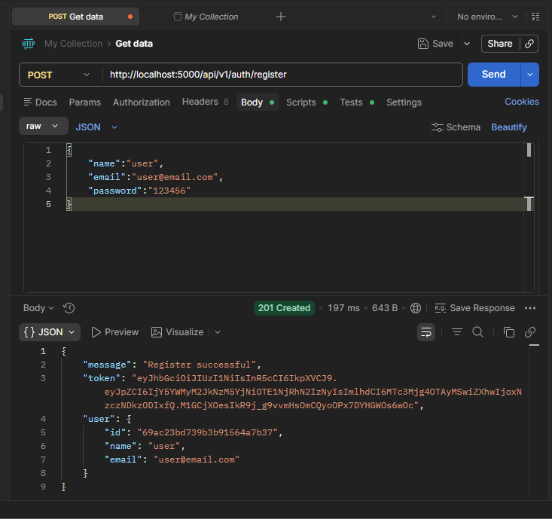

Create Product:
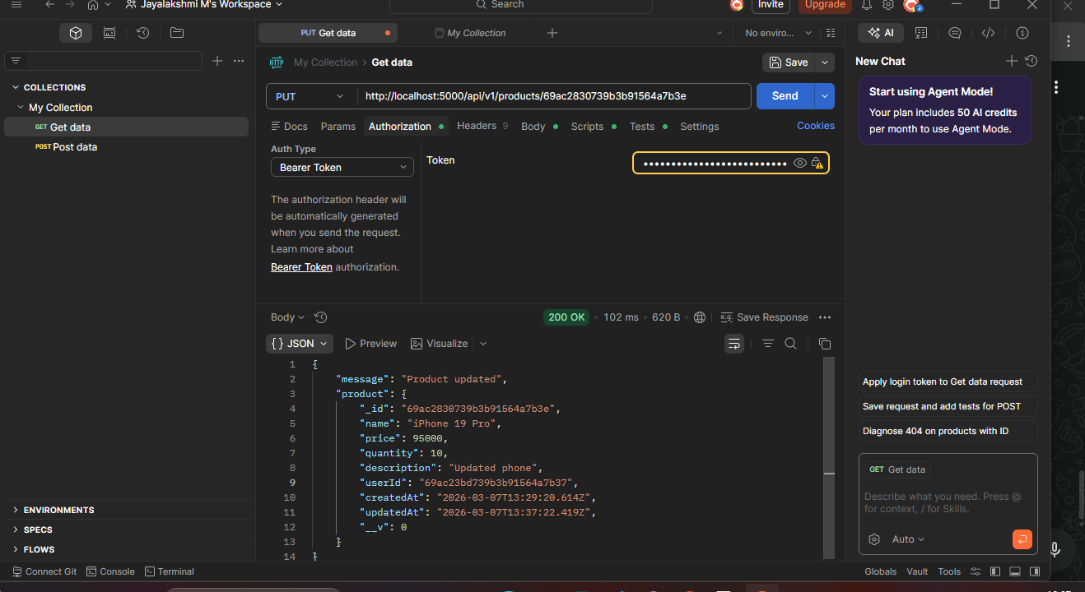

Update Product:


Delete Product:
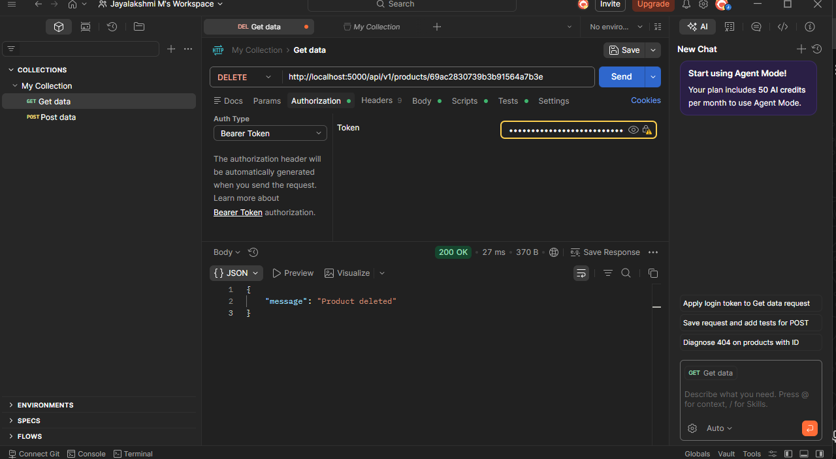

Demo video: https://drive.google.com/file/d/1k7lb2OcSgnsEd4YOrvtBFjmx5c3kJBBl/view?usp=drivesdk

